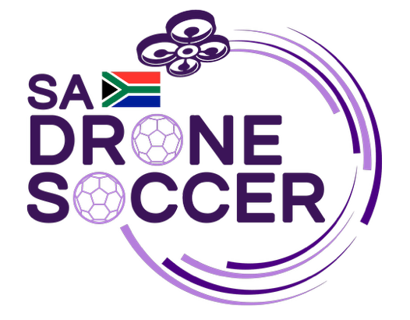
Best Regards,
Queen Ndlovu
SA Drone Soccer
+27 79 3195385 | info@sadronesoccer.com
Hello.

To :
Whom it may concern
Subject :
Project Update
July 27, 2025
+27 79 319 5385
info@sasronesoccer.com
www.sadronesoccer.com

The Innovation Hub,
Lynwood, Pretoria

